

END SEMESTER EXAMINATION – NOV / DEC 2025

Course Code | 21AE3002 | Duration | 3hrs
Course Title | ADVANCED STRUCTURAL ANALYSIS | Max. Marks | 100

Q. No. | Questions |  | CO | BL | M
PART – A (5 X 16 = 80 MARKS)
(Answer any five from the following)
1. | a | Derive the two-dimensional strain compatibility condition for a linearly elastic body under small deformations. | CO1 | A | 8
 | b. | A two-dimensional elastic body has the following strain components:  $ε_{x}​=αy^{2}+2y,$ $ε_{y}​=4x+6y$ $and γ_{xy}​=2x+4y.$ Using the 2-D strain compatibility equation, determine the value of α that ensures a continuous displacement field exists. | CO1 | A | 8
2. |  | A plane stress element has normal stresses σ_{x}, σ_{y}​ and shear stress τ_{xy}​. Using Mohr’s circle, derive the general expressions for the stresses (σ_{x′}​, σ_{y′}​ and τ_{x′y′}​) on an oblique plane rotated by an angle θ from the x-axis. | CO2 | An | 16
3. |  | A cantilever beam of length L = 2.0 m has a rectangular cross-section with a width of b = 50 mm and a depth of h = 100 mm. The beam is subjected to an axial compressive load N = 15 kN and a vertical concentrated load P = 800 N acting downward at the free end. Take the positive x-axis along the beam’s length and the y-axis vertically upward from the neutral axis. Assuming linear elasticity and small deformations, determine (a) the normal stress distribution σ_{x}(y) and (b) the location of the neutral axis with respect to the centroidal axis. | CO3 | An | 16
4. |  | Starting from the two-dimensional equilibrium equations of elasticity (neglecting body forces), prove that $∇^{2}(σ_{xx}+σ_{yy})=0$ for plane strain conditions. | CO4 | A | 16
5. |  | Solve the equation for a beam under pure bending as shown in the figure, and using the theory of elasticity (Airy’s stress function approach), show that the resulting stresses satisfy equilibrium and boundary conditions.  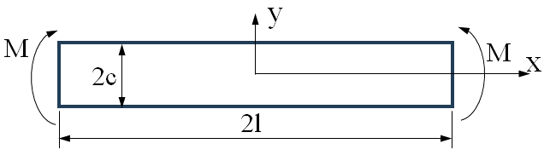 | CO5 | A | 16
6. |  | A thick cylinder with inner radius ‘a’ and outer radius ‘b’ is subjected to internal ($p_{i}$) and external ($p_{o}$) pressure. Determine the stresses induced in the cylinder.  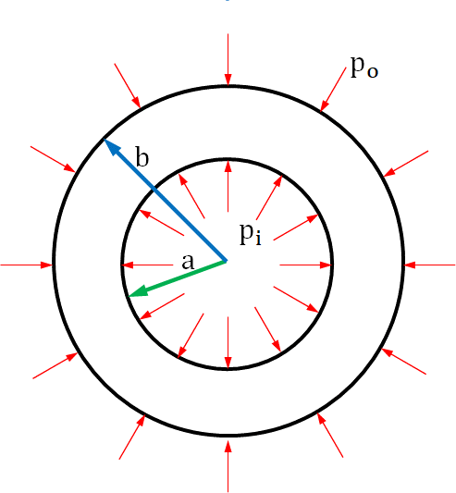 | CO6 | A | 16
7. |  | The displacement field components at a point are given by:  $u=-0.0001y^{2}+0.0015xyz,$ $v=0.0002x^{2}y+0.0003x^{2}z,$  $w=0.0015xyz+0.0002x^{2}yz.$Determine the strain tensor at a point (2, 3, 1). | CO1 | A | 16
PART – B (1 X 20 = 20 MARKS) [Compulsory Question]
8. |  | Show that Airy’s stress function $ϕ=A\left({xy}^{3}-\frac{3}{4}​{xyh}^{2}\right)$ represents the stress distribution in a cantilever beam loaded at the free end with a concentrated load P. Determine the value of A if the shear stress τ_{xy} = 0 at y = ±h/2​, where b and h are the width and depth of the beam, respectively. | CO4 | An | 20

CO – COURSE OUTCOME BL – BLOOM’S LEVEL M – MARKS ALLOTTED

 | COURSE OUTCOMES
CO1 | Understand stress and strain compatibility conditions.
CO2 | Derive Stress-strain relationship of a lamina.
CO3 | Differentiate the symmetrical and unsymmetrical bending.
CO4 | Determine the shear center in various open and closed section of aircraft structures.
CO5 | Analyze the buckling of plates to predict the critical stress.
CO6 | Design aircraft composite panel for aerospace applications.

